Project Planning Phase
Project Planning Template (Product Backlog, Sprint Planning, Stories, Story points)

Date | 18 JUNE 2026
Team ID
Project Name | SHOPEZ: E-COMMERCE APPLICATION
Maximum Marks | 5 Marks

Product Backlog, Sprint Schedule, and Estimation (4 Marks)
Sprint | Functional Requirement (Epic) | User Story Number | User Story / Task | Story Points | Priority | Team Members
Sprint-1 | Authentication | USN-1 | As a customer, I can register an account. | 4 | High | Team
Sprint-1 | Authentication | USN-2 | As a customer, I can log in securely using my credentials. | 4 | High | Team
Sprint-1 | Authorization | USN-3 | As an admin, I can access admin functionalities based on my role. | 5 | High | Team
Sprint-2 | Product Management | USN-4 | As an admin, I can add products with details and images. | 7 | High | Team
Sprint-2 | Product Management | USN-5 | As an admin, I can update and delete products. | 6 | High | Team
Sprint-3 | Product Browsing | USN-6 | As a customer, I can browse available products. | 4 | High | Team
Sprint-3 | Product Search | USN-7 | As a customer, I can search products based on category, brand, or price. | 4 | High | Team
Sprint-4 | Shopping Cart | USN-8 | As a customer, I can add products to my shopping cart. | 8 | High | Team
Sprint-4 | Order Management | USN-9 | As a customer, I can place orders and track order status. | 6 | High | Team
Sprint-4 | Payment Integration | USN-10 | As a customer, I can pay securely using online payment methods. | 7 | Medium | Team
Sprint-5 | Administration | USN-11 | As an admin, I can manage users, products, and orders. | 8 | High | Team
Sprint-5 | Recommendation System | USN-12 | As a customer, I can receive product recommendations. | 5 | Medium | Team
Sprint-5 | Branding & Documentation | USN-13 | As a developer, I can complete project branding and documentation. | 5 | Medium | Team
Total Story Points = 73

Project Tracker, Velocity & Burndown Chart
Sprint | Total Story Points |  |  | Duration |  |  | Sprint Start Date |  |  | Sprint End Date (Planned) |  | Story Points Completed | Sprint Release Date (Actual)
Sprint-1 | 17 |  |  | 3 Days |  |  | Day 1 |  |  | Day 3 |  | 17 | Day 3
Sprint-2 | 13 |  |  | 2 Days |  |  | Day 4 |  |  | Day 5 |  | 13 | Day 5
Sprint-3 | 8 |  |  | 1 Day |  |  | Day 6 |  |  | Day 6 |  | 8 | Day 6
Sprint-4 | 21 |  |  | 3 Days |  |  | Day 7 |  |  | Day 9 |  | 21 | Day 9
Total |  | 73 | 9Days |  | - | - |  | 73 | -

The total estimated effort for the sprint is 73 story points, and the sprint duration is 9 working days.
The team's average velocity per day is calculated as:
$$AV=\frac{\text{Total Story Points}}{\text{Sprint Duration}} \\ AV=\frac{73}{9}=8.11$$
Average Velocity (AV) = 8.11 Story Points/Day
This means the development team is expected to complete approximately 8.11 story points of e-commerce functionality each day during the sprint.

Burndown Chart
A Burndown Chart is a graphical representation of the remaining work versus time in a sprint. In the E-Commerce Website Project, it is used to monitor the progress of features such as user registration, product catalo g management, shopping cart functionality, order management, and payment processing.
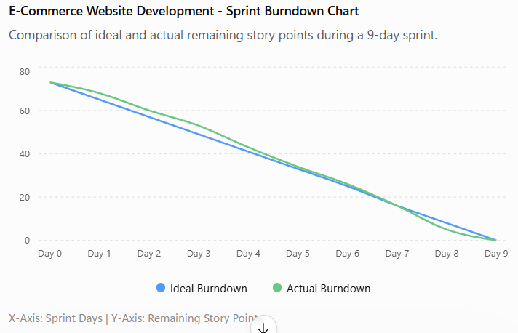
- Track the completion of e-commerce features throughout the sprint.
- Compare actual progress against planned progress.
- Identify delays and bottlenecks early.
- Ensure all sprint backlog items are completed on time.
References
- Atlassian Agile Project Management
- Scrum with Jira Software
- Epics in Agile
- Sprints in Agile
- Agile Estimation
- Burndown Charts Tutorial
- Visual Paradigm Burndown Chart Guide

